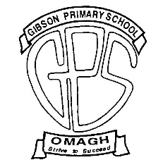
GIBSON PRIMARY SCHOOL
Principal: Mr K Sterritt
64 Old Mountfield Road, Omagh, Co Tyrone, BT79 7EG
Tel: (028) 82244552 Website: www.gibsonps.co.uk E Mail: ksterritt616@c2kni.net

9 May 2023

Dear Parent

As part of our 50th Anniversary Celebrations we are planning a number of events.

Whole School Photograph – Thursday 11 May 2023
We are having a whole school photograph of all pupils and staff which will be on display in school and is also available for purchase. This will be taking place on Thursday 11 May, and we would request that all pupils wear their shirt/blouse and tie to school that day instead of summer dresses or the PE polo shirt.

Celebration Week – 12 June
The main events will be taking place week beginning 12 June.
On Tuesday 13 June we will be holding an Open Evening / Coffee Evening for anyone connected with our school including past staff, governors, pupils and parents. More details about these events will be sent home in the coming weeks.

We will also be having a wide variety of events and activities for our pupils including a dress up day with:
- Year 1 – 3 pupils dressing up in ‘Gold’
- Year 4 – 7 pupils dressing up in the ‘decade’ which they have been studying in class
PTA Meeting
We are having a special PTA meeting on Tuesday 17 May at 7pm to plan the finer details of these activities and will provide more information after this. I would encourage as many as possible to come and help out as this is a great opportunity to do something exciting for our pupils.

I look forward to seeing you all during these events and aim to provide full details in the coming days.

Yours sincerely

K Sterritt (Mr)
Principal

