GIBSON PRIMARY SCHOOL

BOARD OF GOVERNORS’



ANNUAL REPORT

2024 – 2025

THE BOARD OF GOVERNORS

Transferors’ Representatives: Rev J Cowan (Chair) Canon R Clarke Mr W D Reilly Mrs J Vance

Education Authority Representatives: Mr M Beattie (Vice Chairman) Mrs Y Reid

Parents’ Representatives: Mrs R Harper Mr D McIvor
Teacher Representative: Mrs W Irwin
Principal: Mr K Sterritt (Non voting member of the Board)

The Board of Governors is required to meet 3 times each year but in practice meetings occur more often than this. During 2024/2025, the Governors met regarding:
- The Delivery of the Northern Ireland Curriculum
- Staff Appointments, Attendance & Welfare
- Admissions Policy and Open Enrolment
- Self-Evaluation and School Development Planning
- Policy Review
- Budget Management
- Performance Review & Staff Development
- Promoting Positive Behaviour
- Salary Review
- Responding to Department of Education and EA Initiatives
- Child Protection and Safeguarding measures
- Reporting to parents

The Board of Governors was reconstituted in January 2025 and the new Board of Governors for the next 4 years is:

Education Authority Representatives:
Rev J Cowan (Chair) Mrs J Vance (Designated Governor for Child Protection)
Transferor Representatives:
Mr M Beattie (Vice Chair) Mrs Y Reid Canon R Clarke Mr D McIvor
Parents’ Representatives: Mrs L Armstrong Mr M Wilkinson
Teacher Representative: Mrs W Irwin
Principal: Mr K Sterritt (Non voting member of the Board)

ENROLMENT

Enrolment during 2024/25 remained steady with 321 pupils (including the Speech and Language Units) being enrolled which was an increase of 1 pupil on the previous year. Despite this consistent enrolment, significant financial pressures remained.

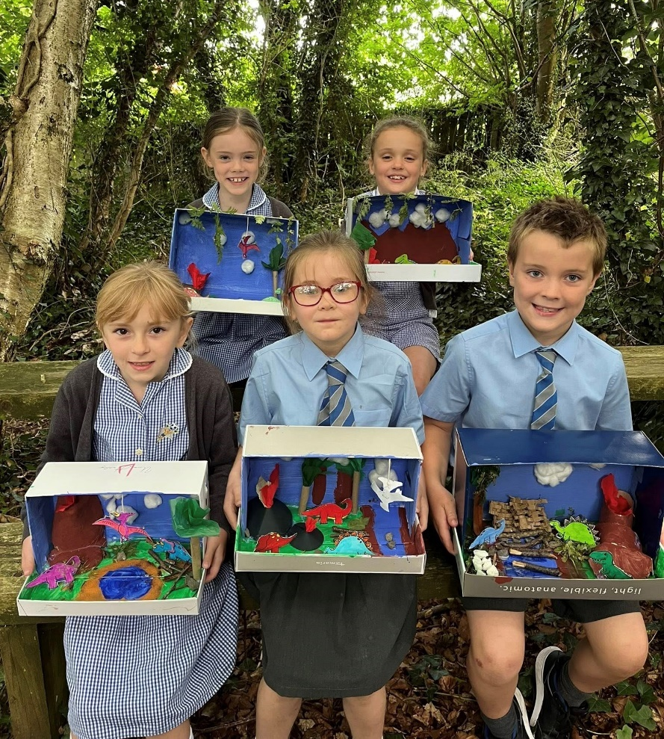
Our pupils’ attendance continued to be in line the Northern Ireland average with the school average being 93.6%. Spells of illness and family holidays during term time were the main absences. Discussion regarding these absences took place at Governor meetings with different initiatives being considered to promote attendance.

CHILD PROTECTION

Our Child Protection Policy is available to view on our school website and is reviewed annually. It is also available in paper copy upon request. Child friendly posters are on display around the school to ensure pupils know who they can talk to. All procedures continue to be fully implemented with criminal background checks and induction training being provided for all newly appointed staff.

Our safeguarding team are:
- Mr Sterritt Designated Teacher
- Mrs Irwin and Mrs Shortt Deputy Designated Teachers

All staff received updated child protection training in August 2024 or when they commenced employment. Our preventative curriculum is delivered during assemblies, in class (PDMU) and through links with other organisations including NSPCC and through various initiatives such as Safer Internet Day.
STAFF STRUCTURE

In the 2024/25 school year, our teaching staff consisted of:

Year 1 Mrs J Anderson Mrs L Doherty
Year 2 Mrs L Simpson Mrs A Pollock
Year 3 Mrs K McMullin Mrs M Walsh / Mrs H Russell (job share)
Year 4 Mr S Elliott Mrs R Browne
Year 5 Mr P Kane
Year 5/6 Mrs J Baird
Year 6 Mrs E Maguire
Year 7 Mrs B Jobb Mrs W Irwin (Vice Principal)
Language Classes Mrs S Shortt Mrs E Davidson / Mrs E Beggs
Principal Mr K Sterritt

Classroom Assistants: R Kyle, V McFarland, C Moss, R Murphy, W Telford, F Fyffe, R McClintock, H Hutchinson, A Loughlin, E Donaghy, E Aiken, V McGonigle, A White, I Neil, K Picking, Y Williams, C Beattie, D Colhoun, R Reid, L Ellis, L Spence, J Knox, H Beattie, J Morton

Executive Officer Mrs D Clarke Senior Clerical Officer Mrs L McFarland

Building Supervisor Mr S Gilfillan / Mr P Adams

Gibson Primary School was left devastated in December 2024 due to the sudden passing of our Building Supervisor, Mr Sydney Gilfillan. Sydney was our Buidling Supervisor for over 13 years and was a loved staff member by staff, pupils and parents alike. A service to mark Sydney’s life was held in school where we celebrated everything he had done for all of us.

Staff Changes
Governors reviewed staffing and made forward plans for the academic year 2025 – 2026.
Mr Paul Adams was appointed as our new Buidling Supervisor, while a small number of classroom assistants retired.
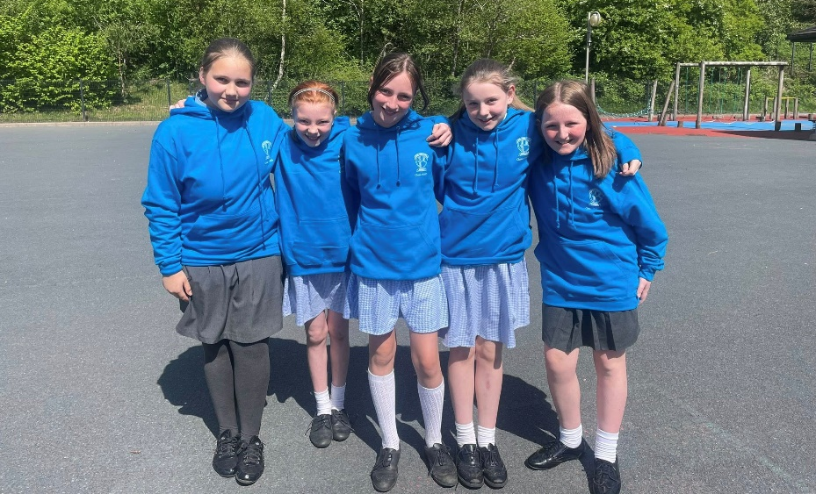

INSERVICE TRAINING

The five ‘Baker’ days in August and five Staff Development Days are key elements of our Continued Professional Development Programme. They were used to plan and prepare for quality learning and teaching and to address specific issues identified in our School Development Plan, as outlined below.
 | DATE |  | FOCUS OF STAFF DEVELOPMENT
Baker Days | Day | Date | The focus for each day should link to, and support, the priorities identified in the school’s development plan.
Day 1 | Tuesday | 22 August | Classroom Preparation and planning  Teacher meetings & Transfer of Information
Day 2 | Wednesday | 23 August | Autism Training (Middletown)
Day 3 | Thursday | 24 August | SDP review  Classroom Preparation, Planning & Data Analysis
Day 4 | Friday | 25 August | Child Protection Refresher Training  Staff meeting – Identification of SDP focus
Day 5 | Tuesday | 29 August | Curriculum Content review and Curriculum Planning  Term 1 Priorities / timetable – Coordinator Action Planning
SDDs | Day | Date
Day 1 | Monday | 28 October | Data Analysis  Literacy, Numeracy & ICT Task identification
Day 2 | Friday | 3 January | Literacy Scheme of Work  Co-ordinator Action Plan Review
Day 3 | Monday | 17 February | Smartboard Training  Update Numeracy Scheme of Work
Day 4 | Monday | 14 April | Data Analysis  ICT, Numeracy & Literacy Focus
Day 5 | Tuesday | 28 May | School Development Plan Review  Report Writing

SCHOOL ACCOUNTS
School accounts are monitored by Governors as a standing item of every meeting. As in previous years all school accounts are audited annually by Watson & Colhoun Chartered Accountants and Registered Auditors. The Board of Governors would like to express their appreciation to the staff at Watson and Colhoun for their professional oversight of our accounts.
Delegated budget funds allocated be the Department of Education are managed by Governors with the assistance of EA LMS (Local Management of Schools) officers. While all schools are reporting challenges financially Gibson Primary School continues to operate within the budget allocation given, although this is becoming more and more challenging.

SPECIAL EDUCATIONAL NEEDS
We continue to support pupils with Special Educational Needs in a wide variety of ways with our recently refurbished Sensory Room being widely used. We also have specially trained Classroom Assistants who support pupils on a 1-1 basis as well as withdrawing those pupils who require additional assistance learning their key words or sounds.

SCHOOL LIFE

Year 1
46 new Year 1 pupils joined us in September and settled in extremely quickly. Lots of fun events including Nursery Rhyme Day and visits to the school forest took place. We also had lots of school visitors relating to their ‘People who help us’ topic.

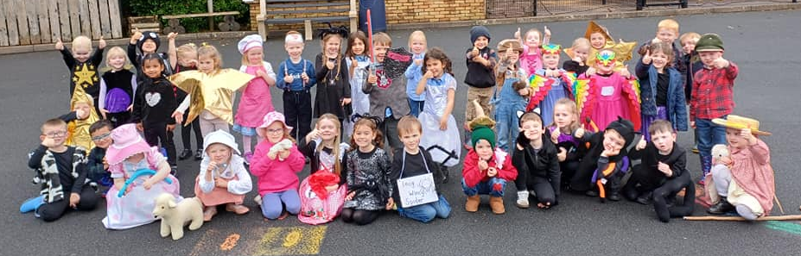

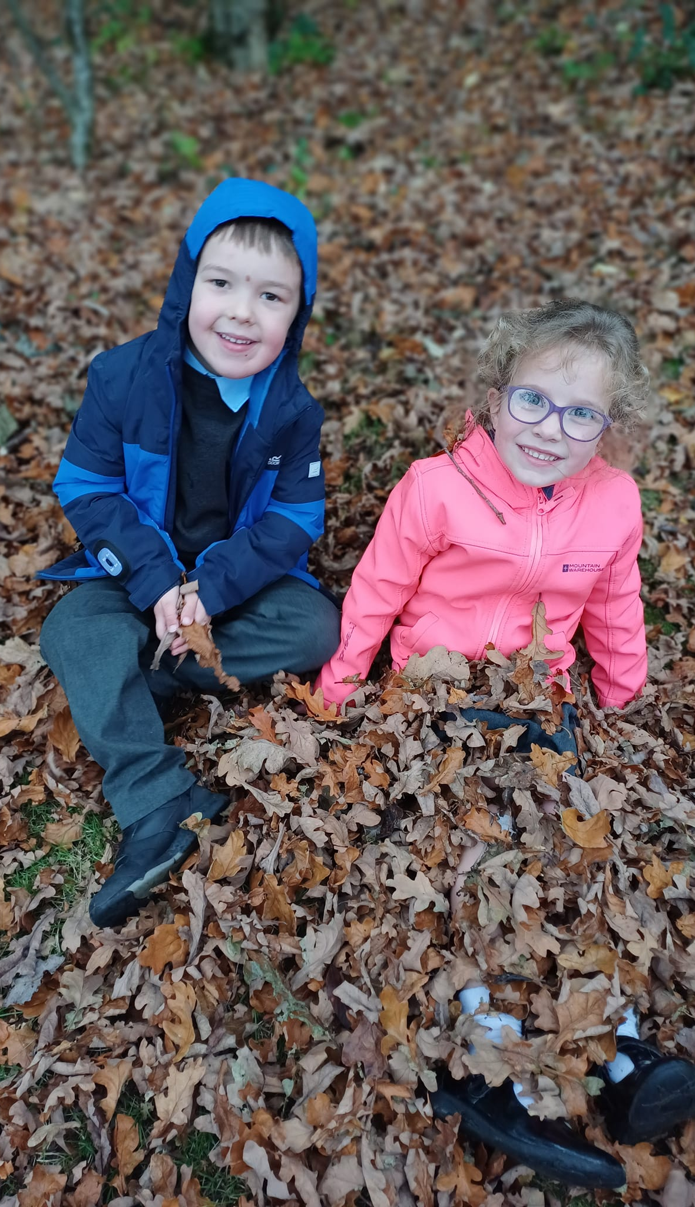
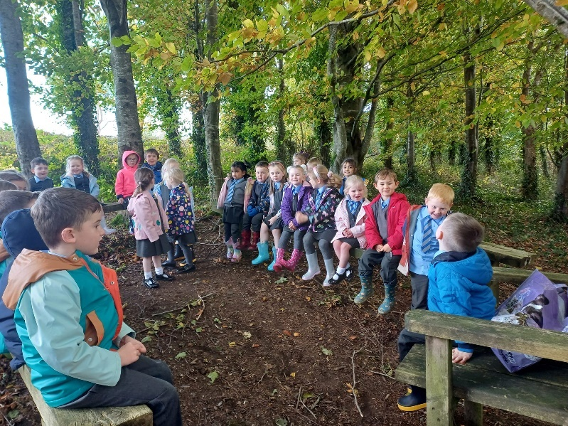

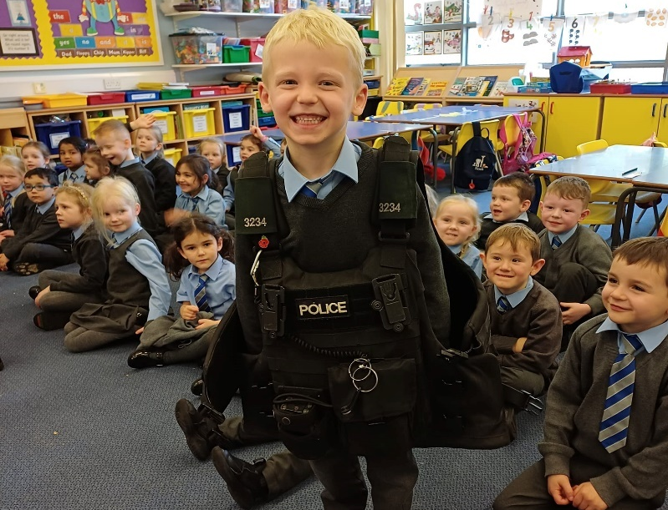

Wrap Around Care
We continued to offer Wrap Around Care in the form of our Breakfast Club and After School Provision. Both of these services continued to thrive with an average of over 150 pupils attending on a weekly basis.

PTA Events
Once again our PTA events proved extremely popular and included Halloween Disco, Christmas Fun Days, Easter Raffles and a Summer Carnival. A Glow Disco was also held at the request of our School Council. The PTA supported the purchase of additional resources to school with over £2,000 being used to re-stock our school library.
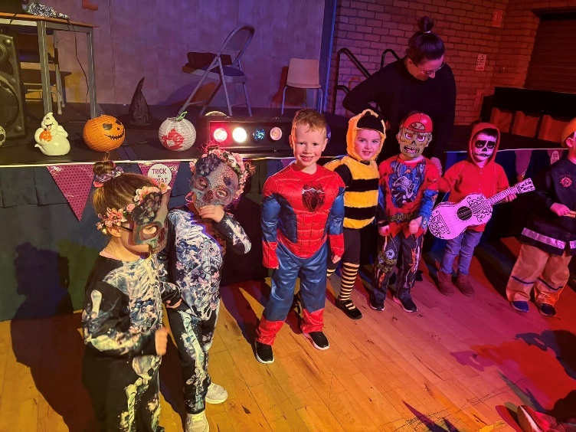
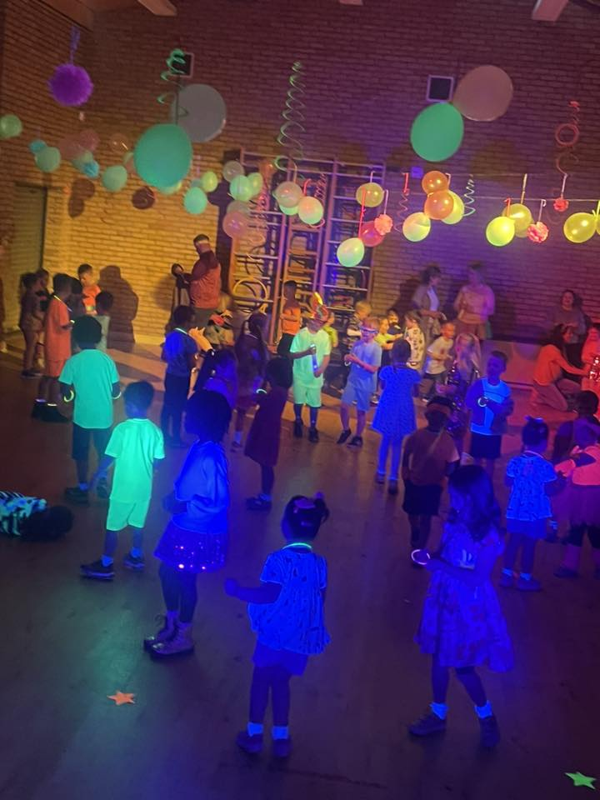

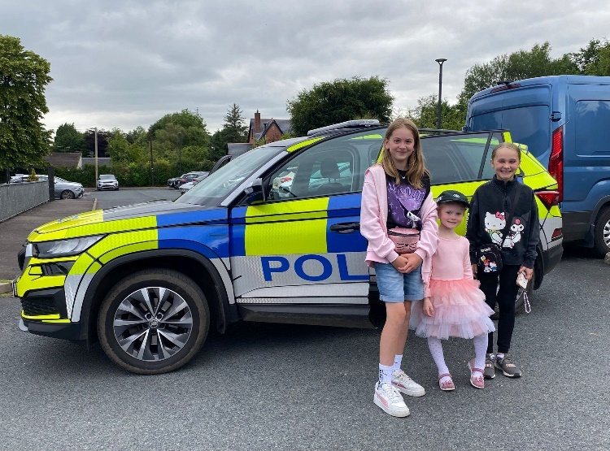

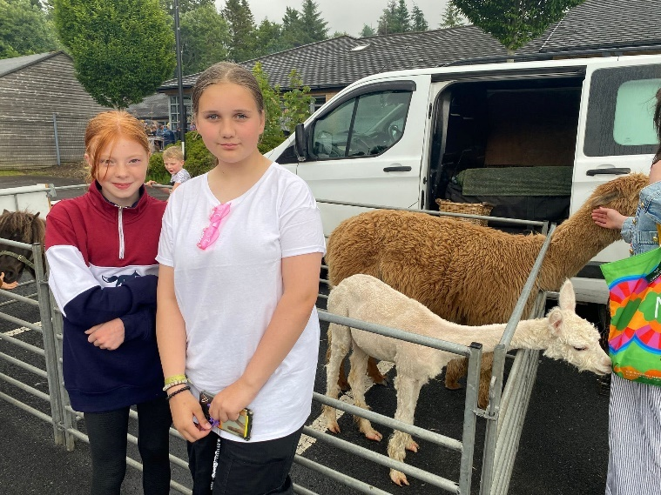
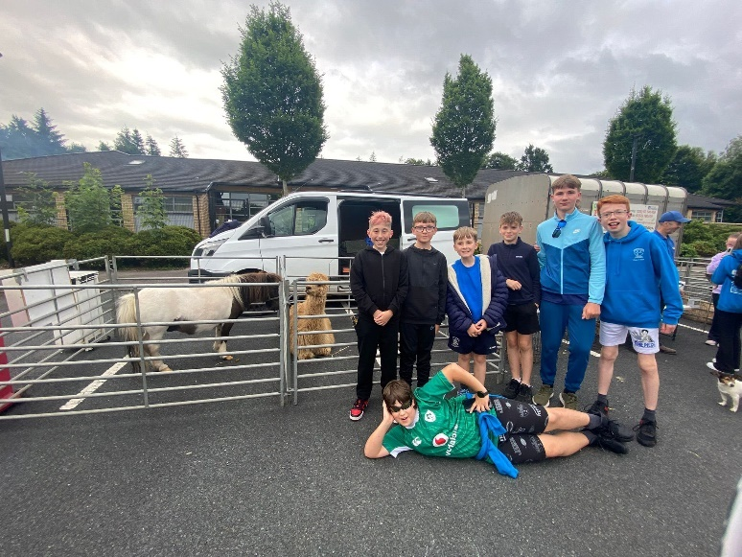

Once again Santa arrived in a different way this year coming on his motorbike. Unfortunately, however two of his elves thought it would be funny to steal the children’s presents. Thankfully Santa was able to catch the two elves and send them back to the North Pole, not before they drove their bikes into Mrs Browne’s classroom!


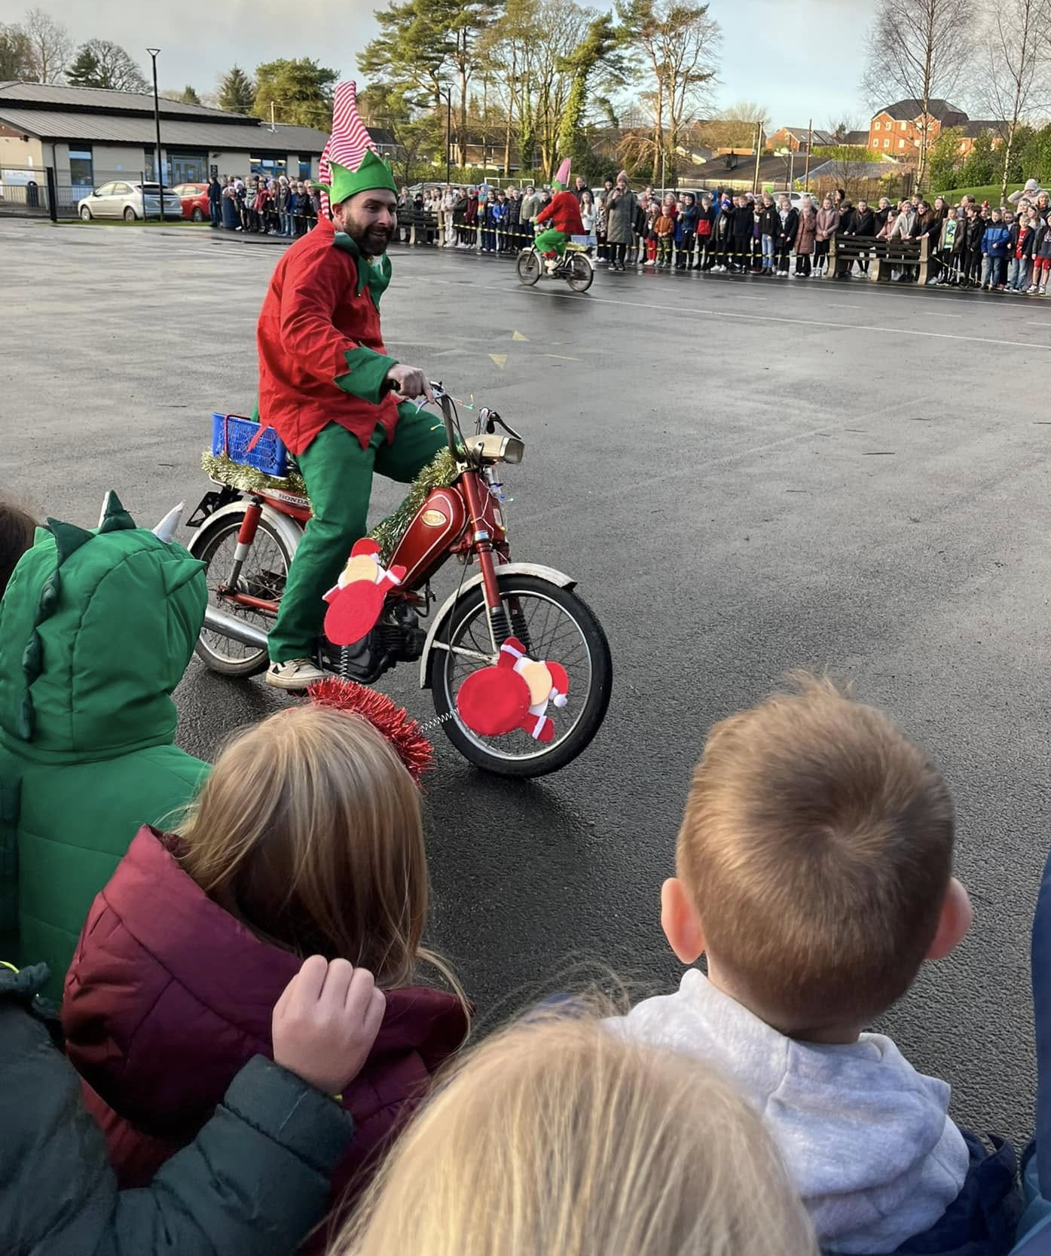

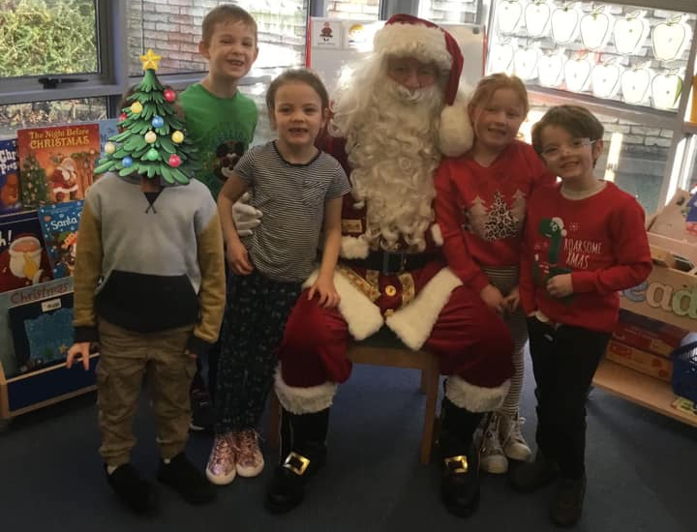

Additional Curricular Activities
Building on our initiative last year to ensure all our pupils experienced a widest range of additional activities we continued to offer additional activities on Monday and Friday afternoons during the school day. The pupils were able to participate in:
Running, Fitness, Rugby, Multisport, Hockey, Outdoor Play, Orienteering, Forest Friends, Cookery, Languages, Yoga/Mindfulness, Construction and many more!
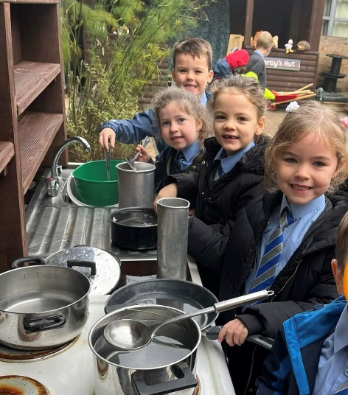
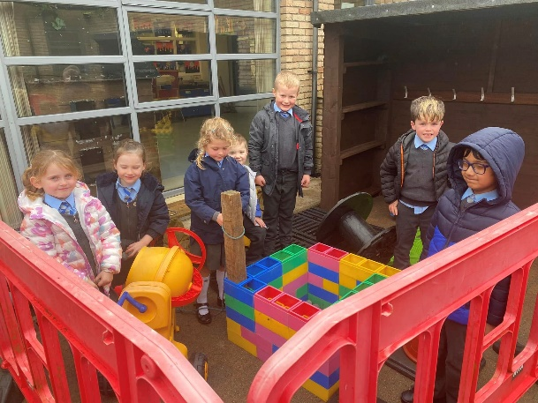
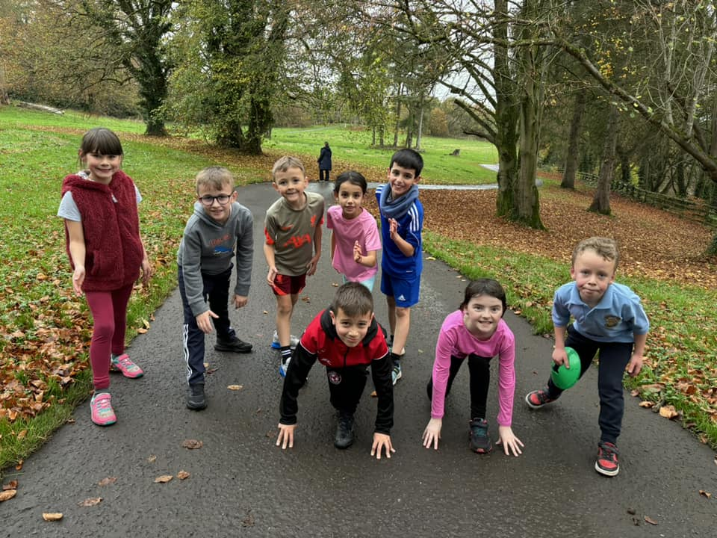

Year 6 & 7 Residential School Trip
For the first time since Covid-19 our residential trip returned overseas to Edinburgh. A total of 63 pupils and 7 staff members travelled, laughed, ate, jumped and generally had the best time. It was lovely to see the pupils mature and represent our school in the best way possible!
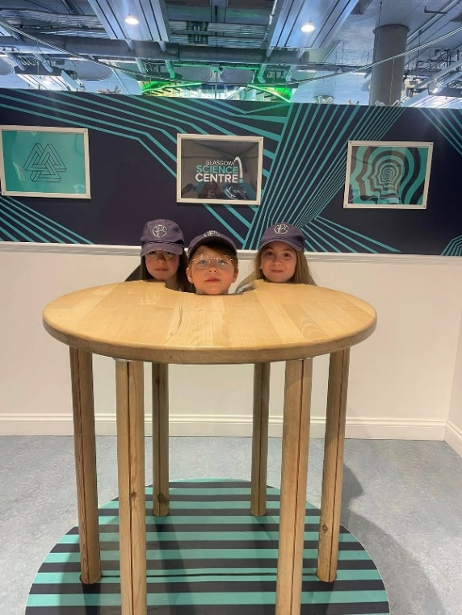

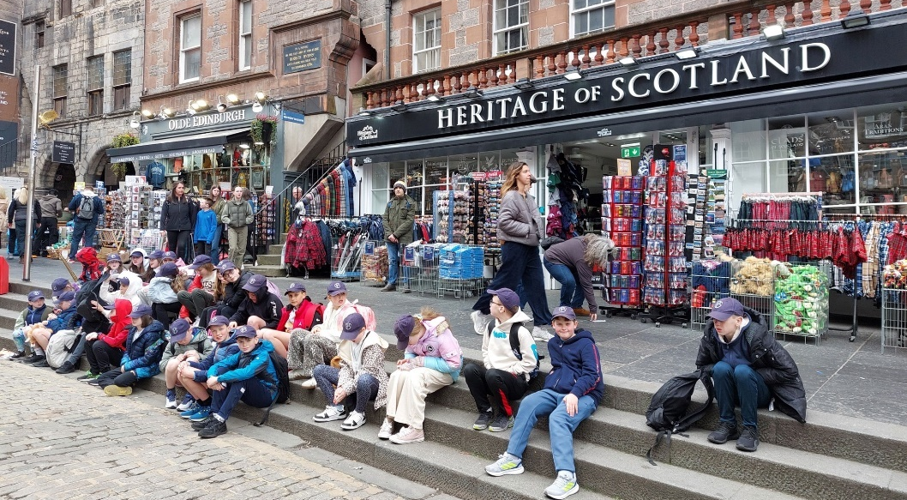

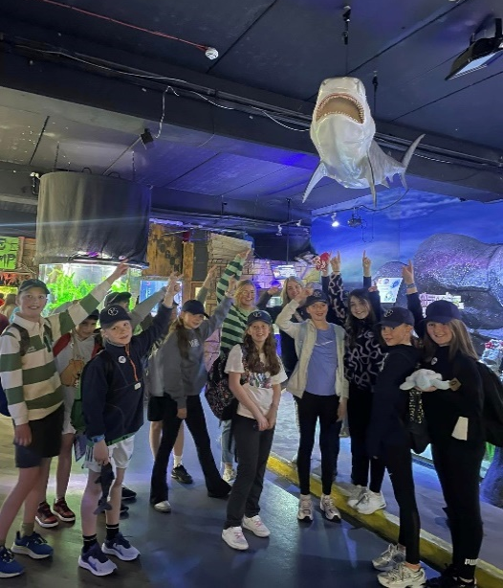
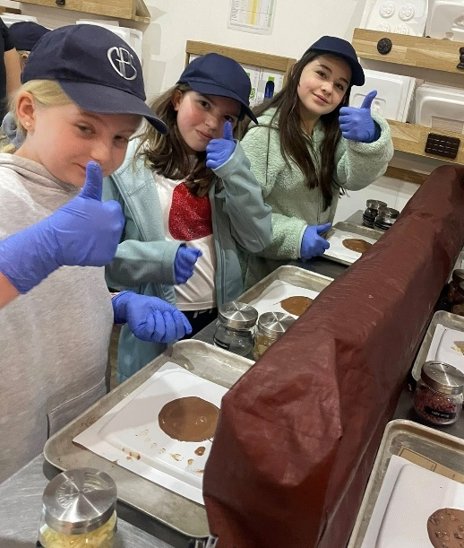
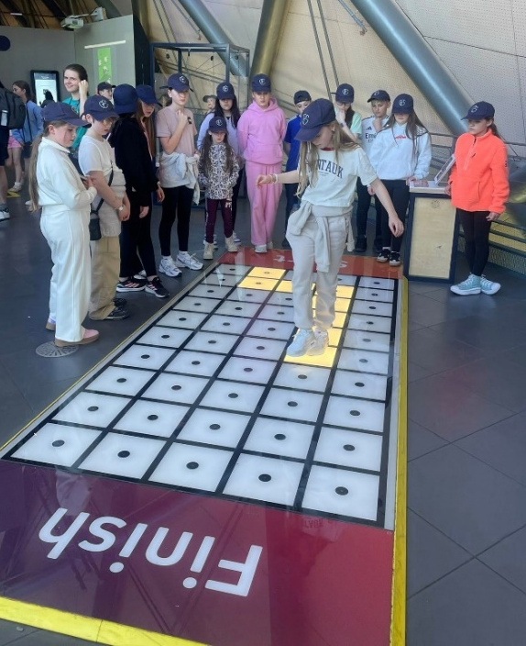

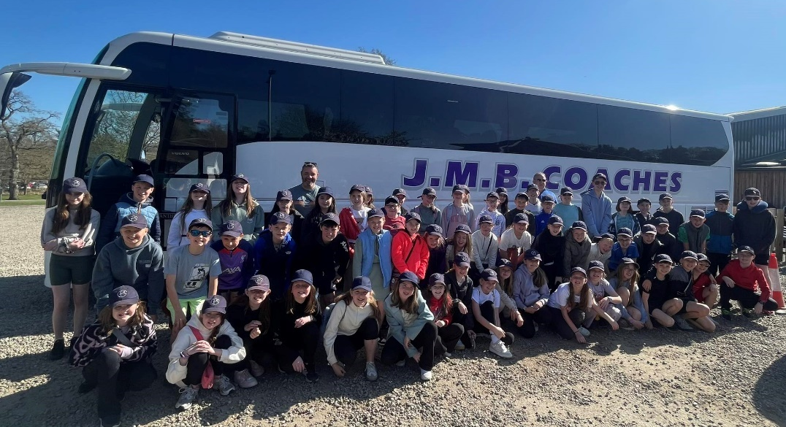

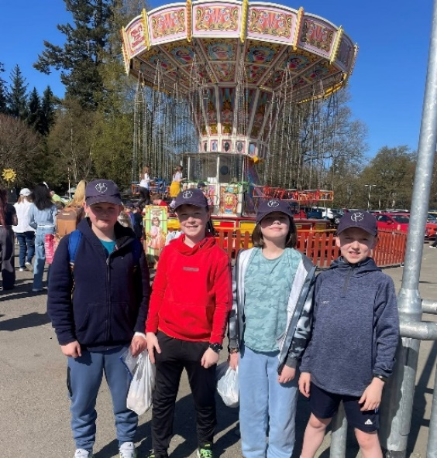

Sporting Activities
Our pupils once again took part in numerous different competitions and events representing the school with commitment and excellent sportsmanship.
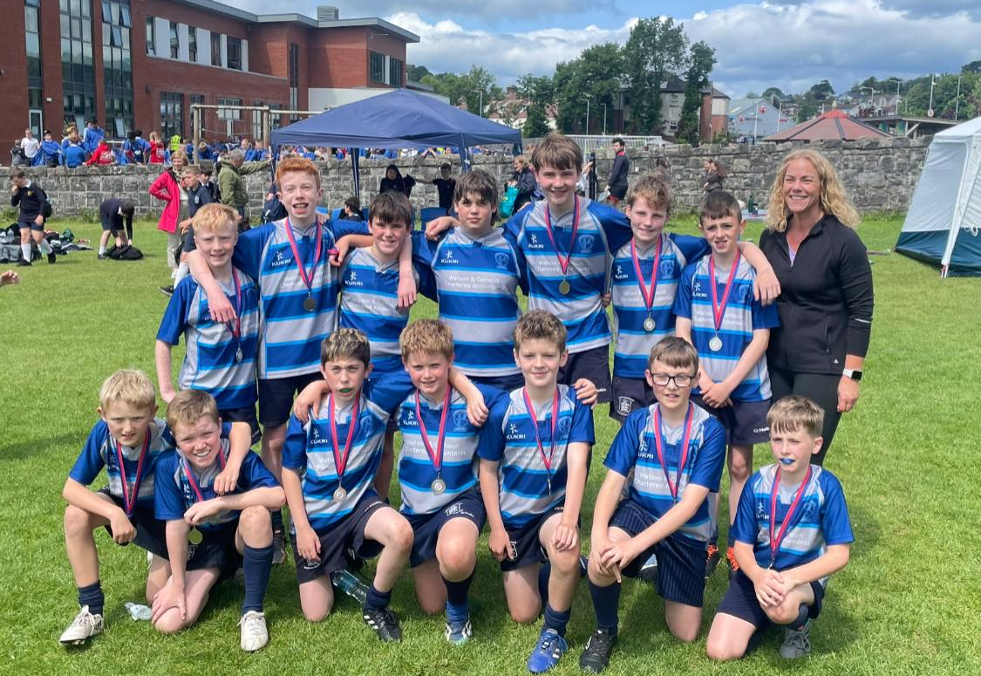
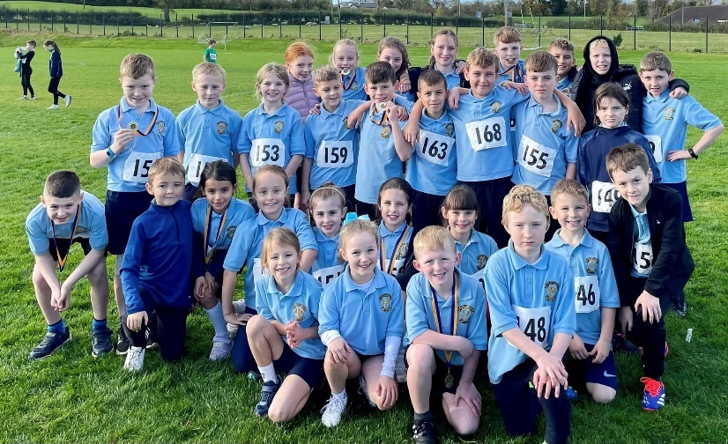

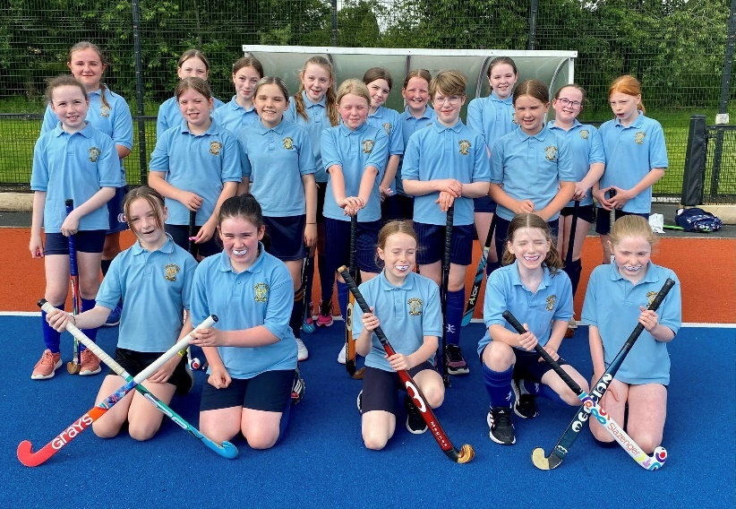
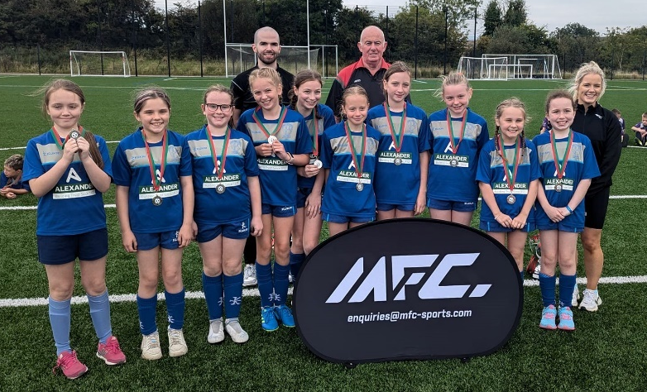

Sports Day
We were blessed by the weather as over 200 parents watched our pupils participate in a number of different events with a high level of talent and sportsmanship on display!
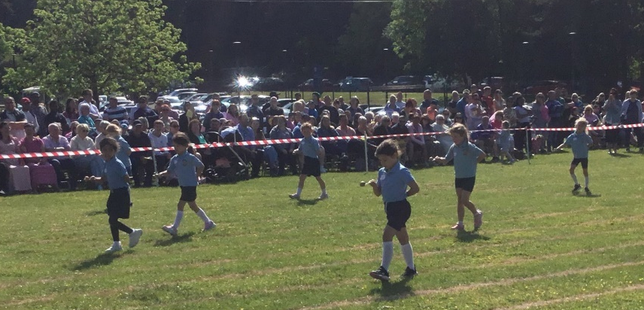
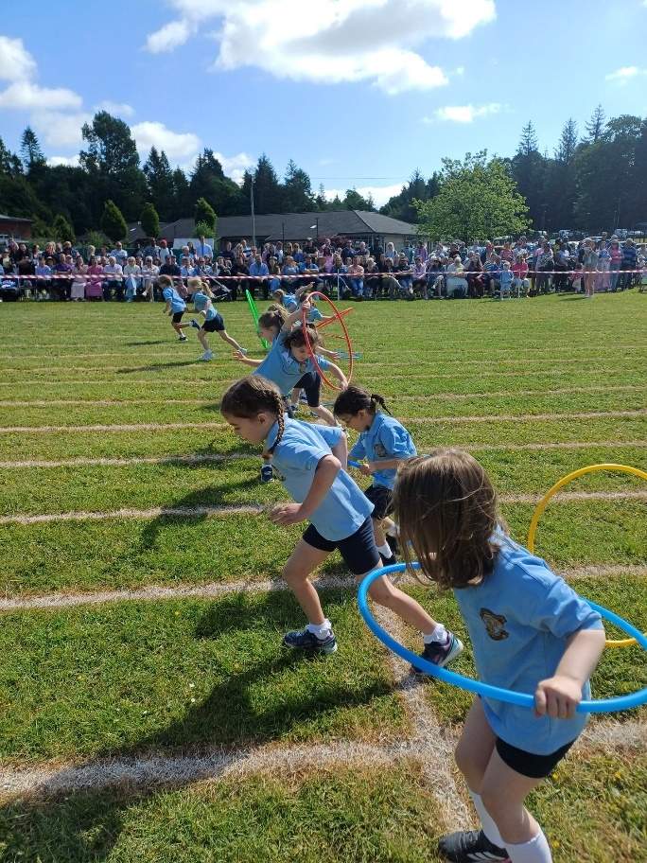

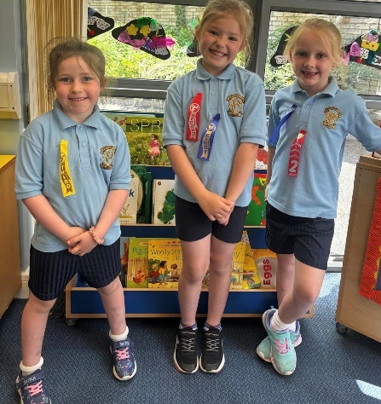
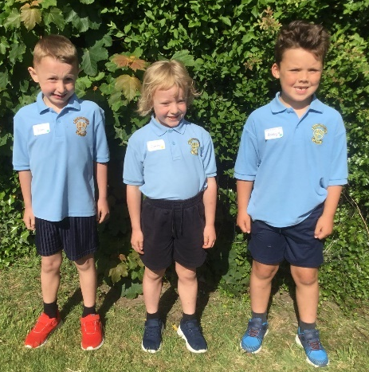

Educational Visits and Outdoor Learning
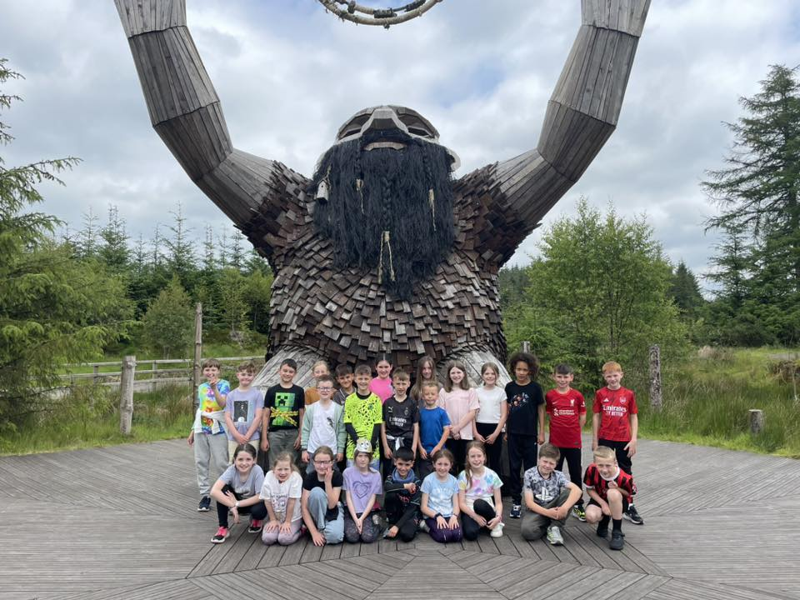
Our pupils had many opportunities to investigate their surroundings and visit places of interest which furthered their learning and enabled them to apply the knowledge and skills learned within the classroom in a different context. We firmly believe that learning beyond the classroom is key to fostering interest and enthusiasm.
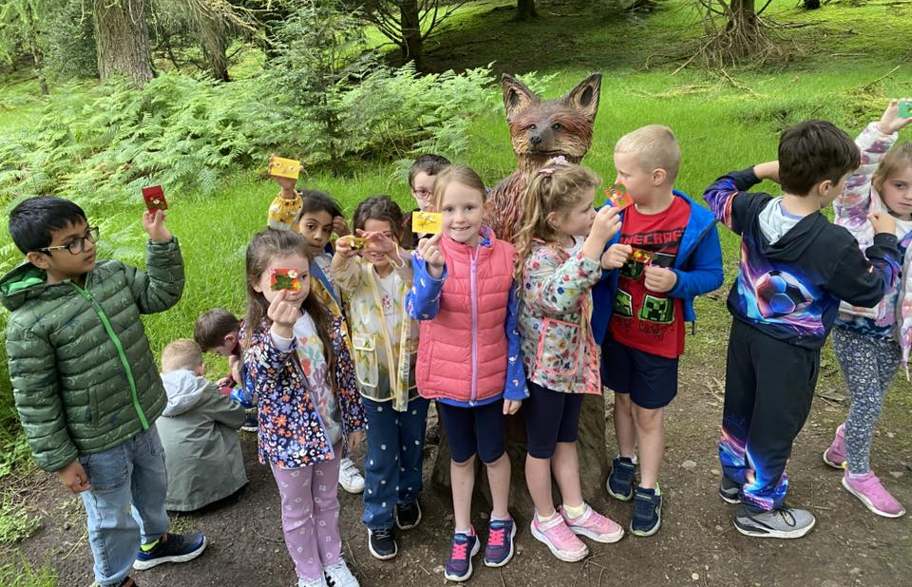

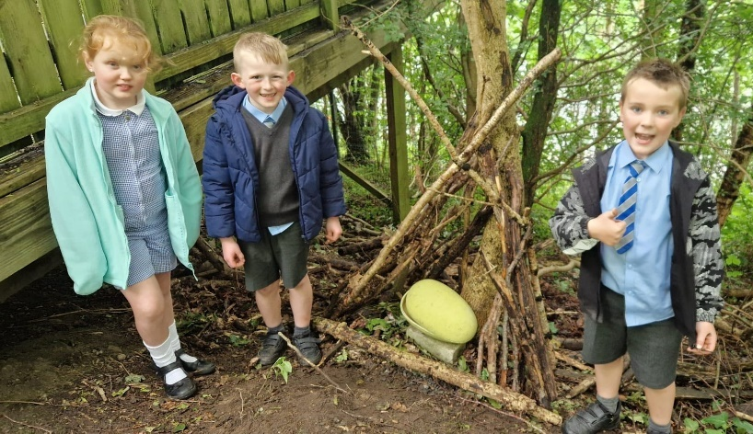
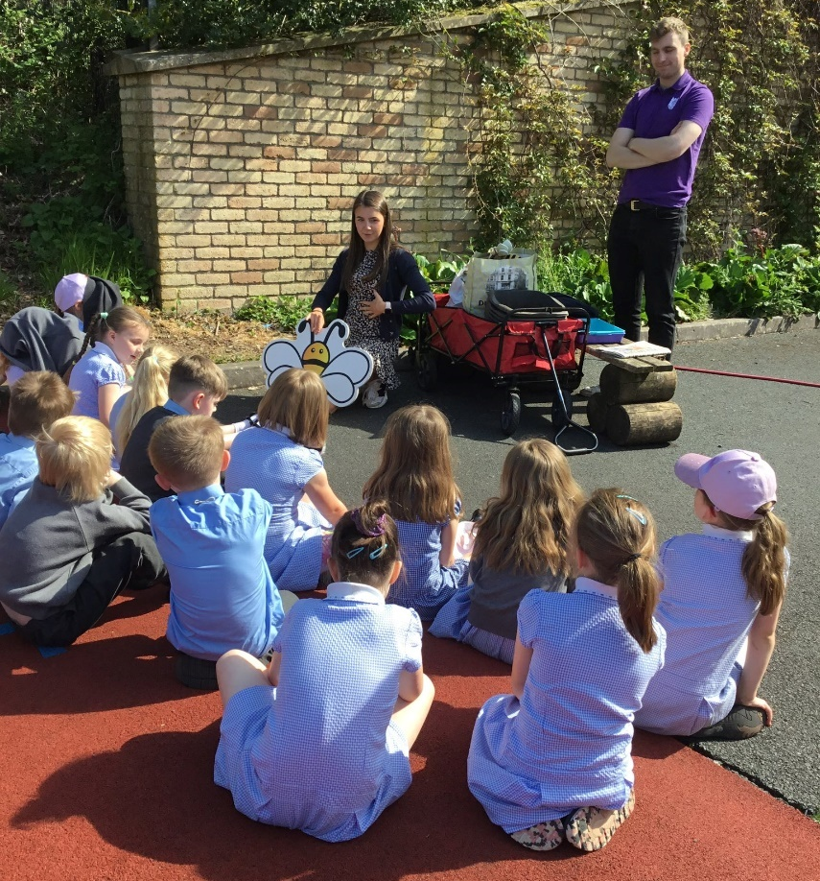

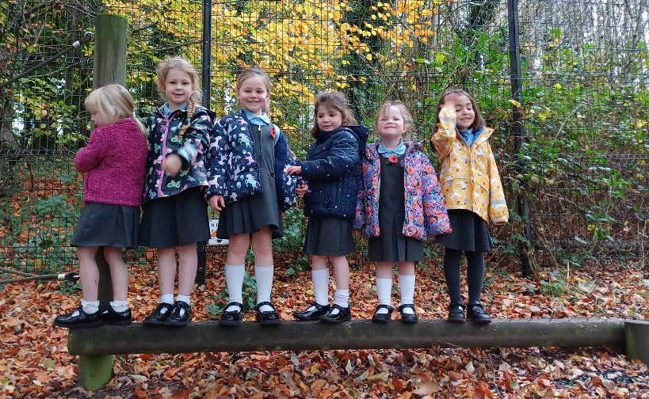

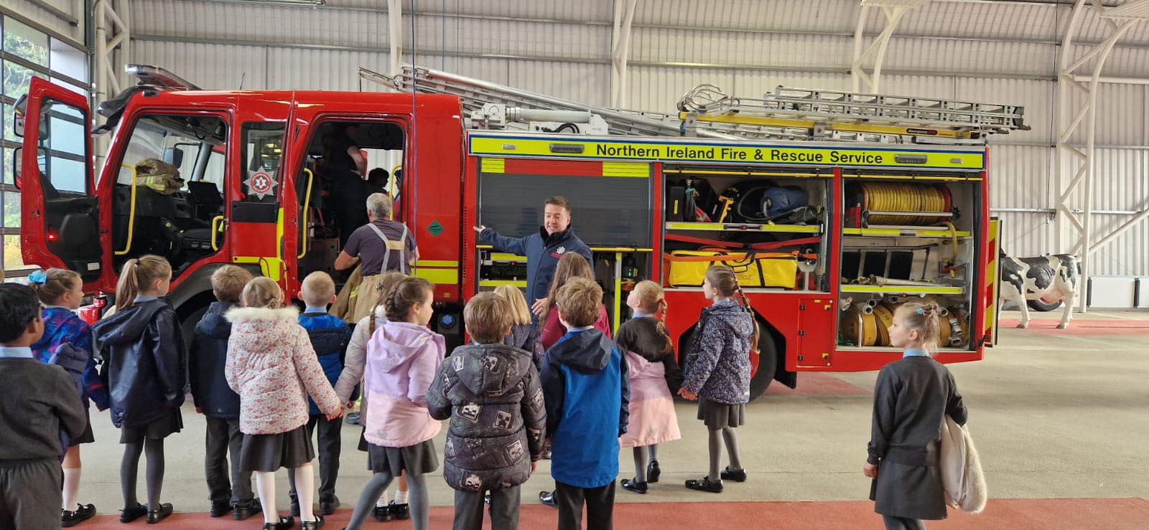

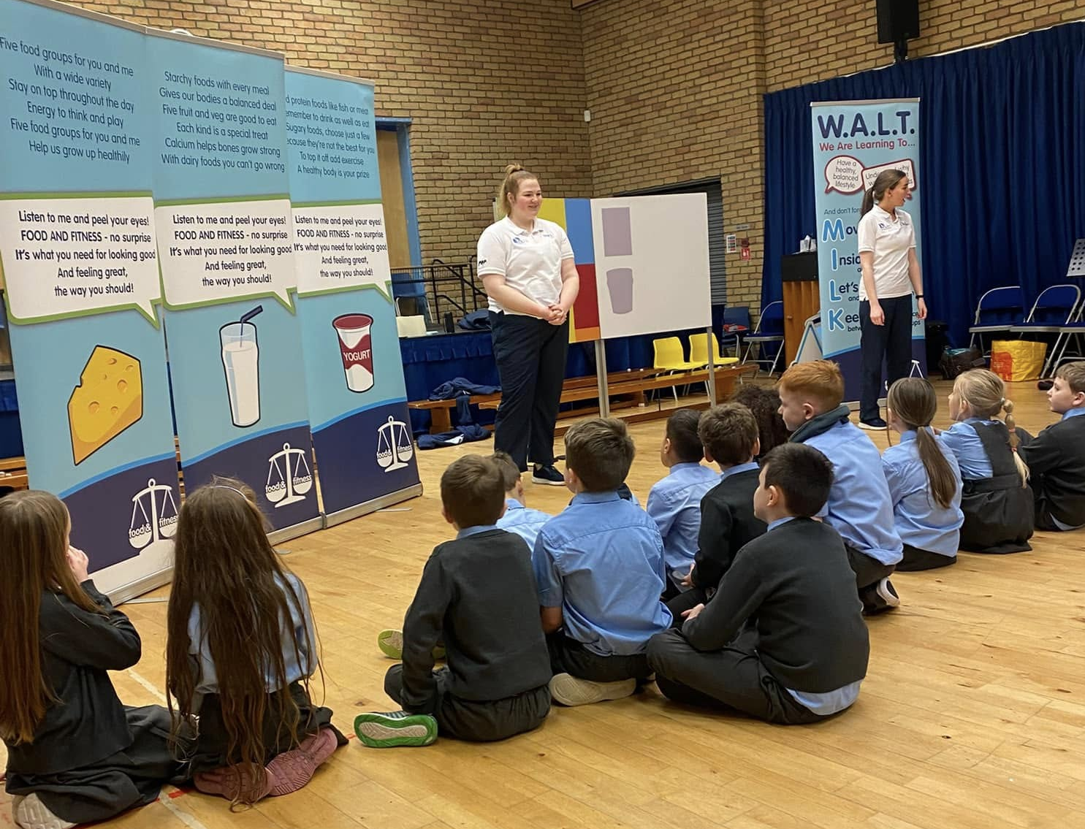
Visitors to School
Not only did our pupils visit a number of different places we also had visitors to class who helped our pupils learn about different jobs, different roles and different people who can help us.

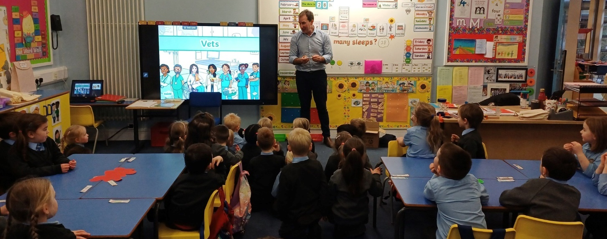

Special Events in School
A number of themed days also took place with World Book Day and Pancake Tuesday proving as popular as ever! Pupils in our Speech and Language Classes also celebrated Development Language Disorder Day.
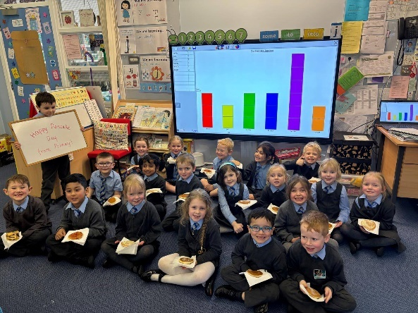
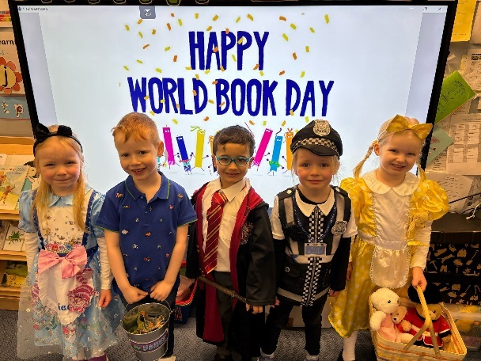

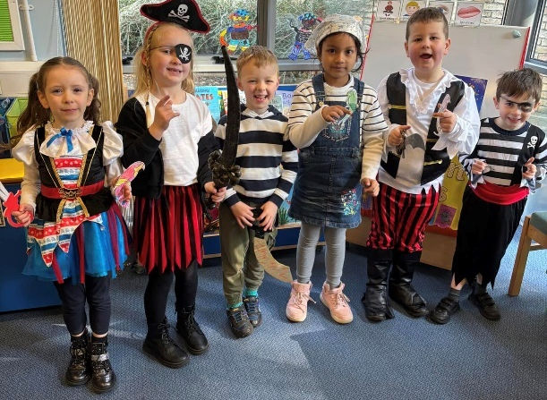

Our school choir also performed both inside school and within the community visiting local Nursing Homes, community events, churches and charities taking place, as well as performing for the rest of the pupils in Friday assemblies.
Our pupils also perfomed at Omagh Feis and for the first time we ran a number of Sustrans programmes aimed at developing healthier and more environmentally friendly ways of thravveling to school.
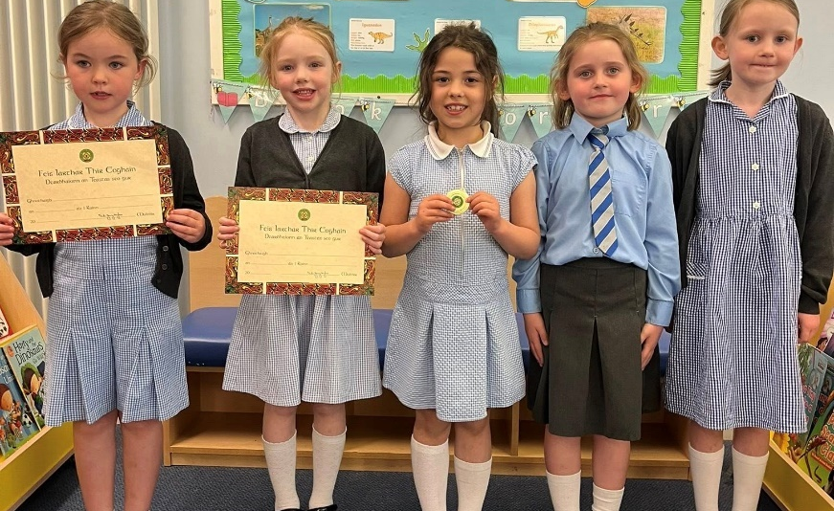
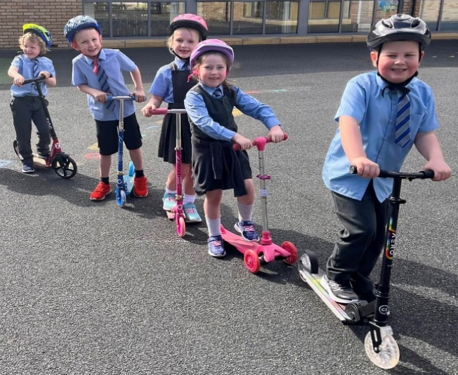

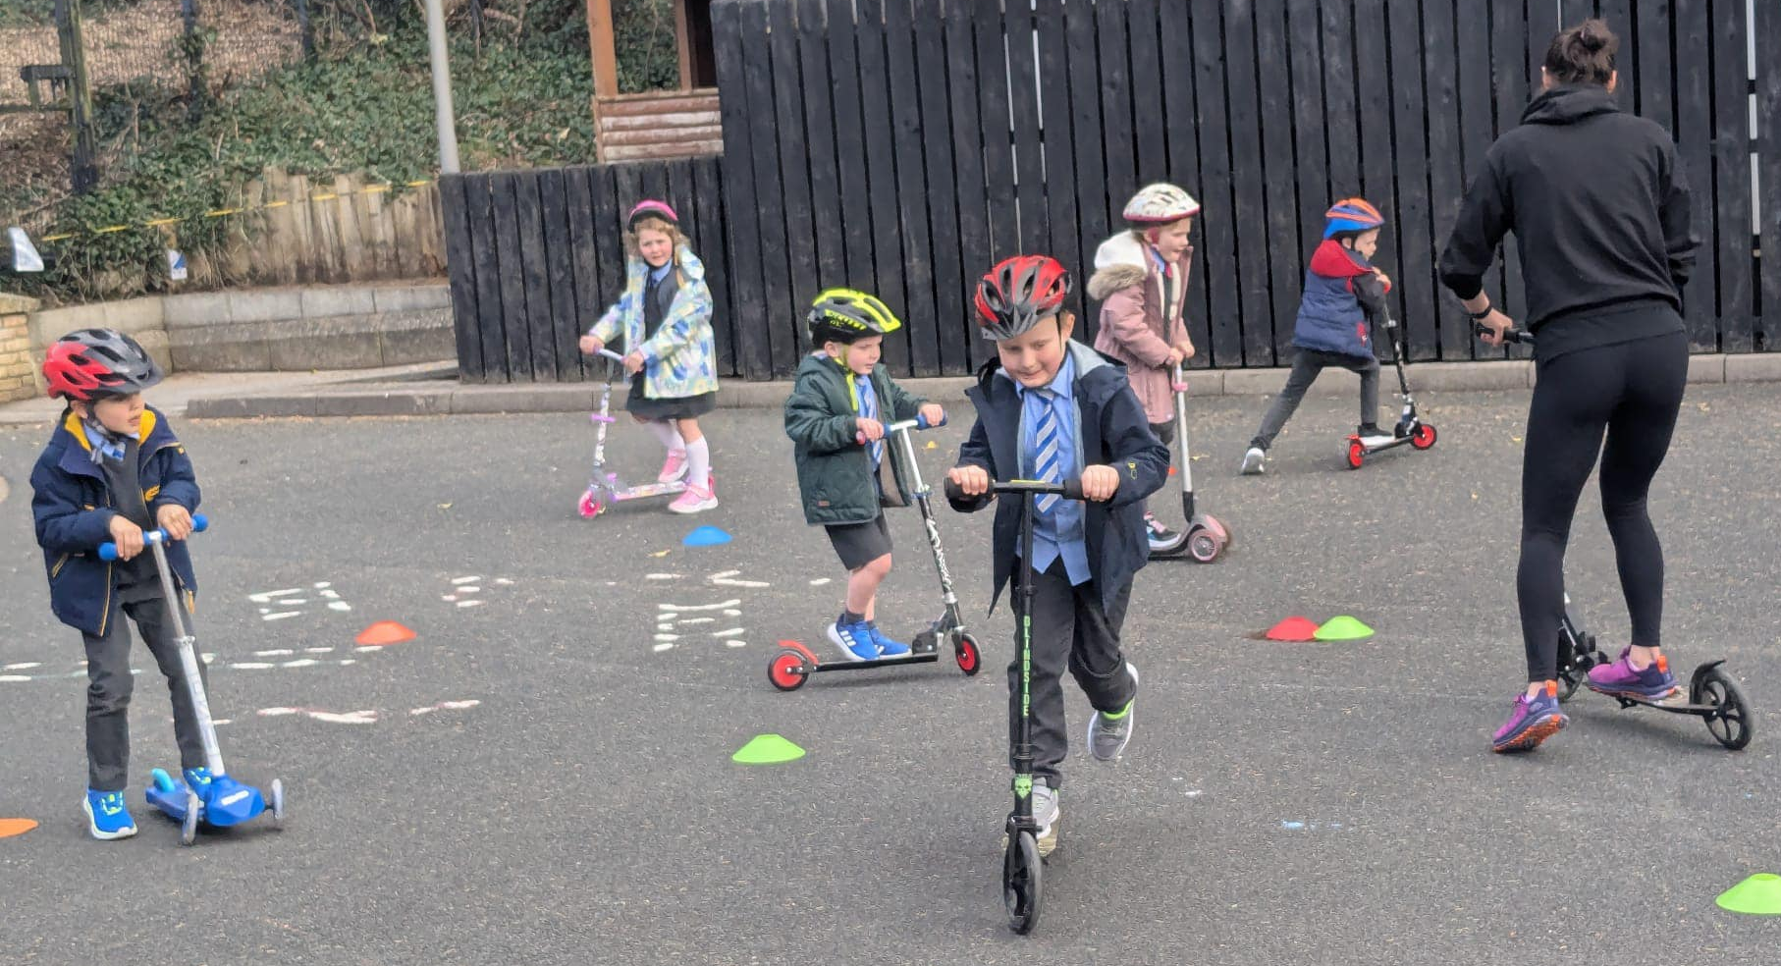
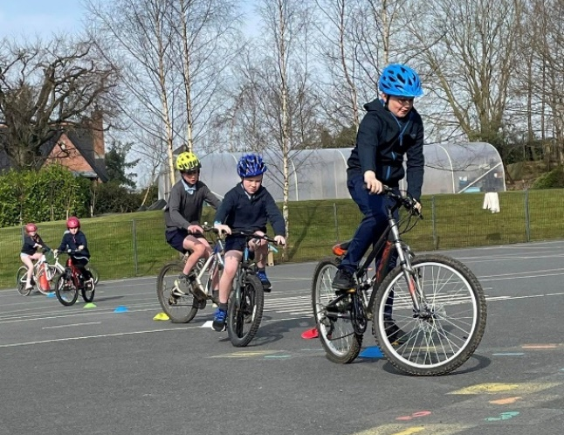

Chirstmas
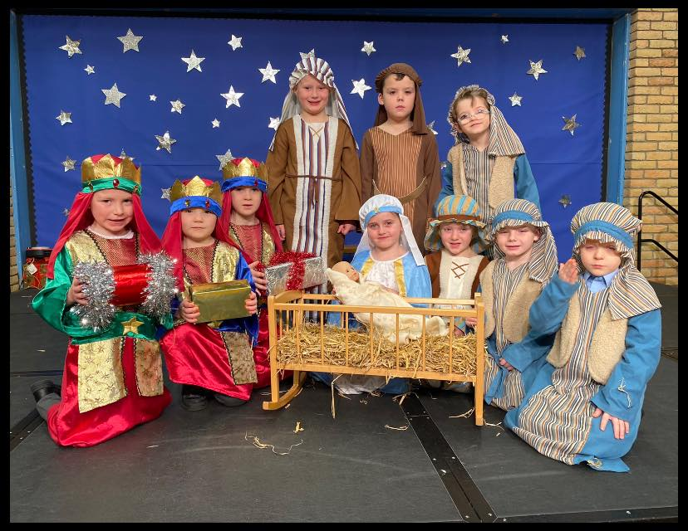
Christmas Performances once again were the highlight of term 1 with all classes having the opportunity to perform for their families and friends. As usual the pupils performed magnificently and showed just how amazing they are!
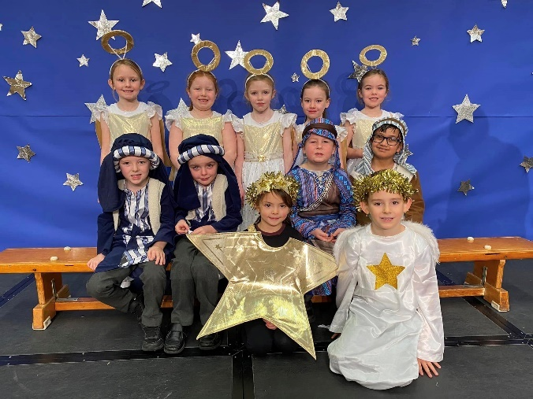

This completes our Governors’ Report for the 2024/2025 school year. While it only gives a flavour of what has happened it shows we have a lot to celebrate and remember in the course of one year. We are thankful for our Staff, Parents and pupils and for their support and hard work throughout the year.

